**UNIVERSITAS MUHAMMADIYAH PONOROGO**

**FAKULTAS KEGURUAN DAN ILMU PENDIDIKAN**

**(STATUS TERAKREDITASI)**

Alamat : Jl. Budi Utomo No. 10 Telp. (0352) 481124 Fax. (0352) 461796

Ponorogo – 63471

APPROVAL PAGE

This is to certify that the Sarjana’s thesis of **ROHMA FITRIANI** has been approved by the Board of Examiners as the requirement for the degree of Sarjana in English Education.

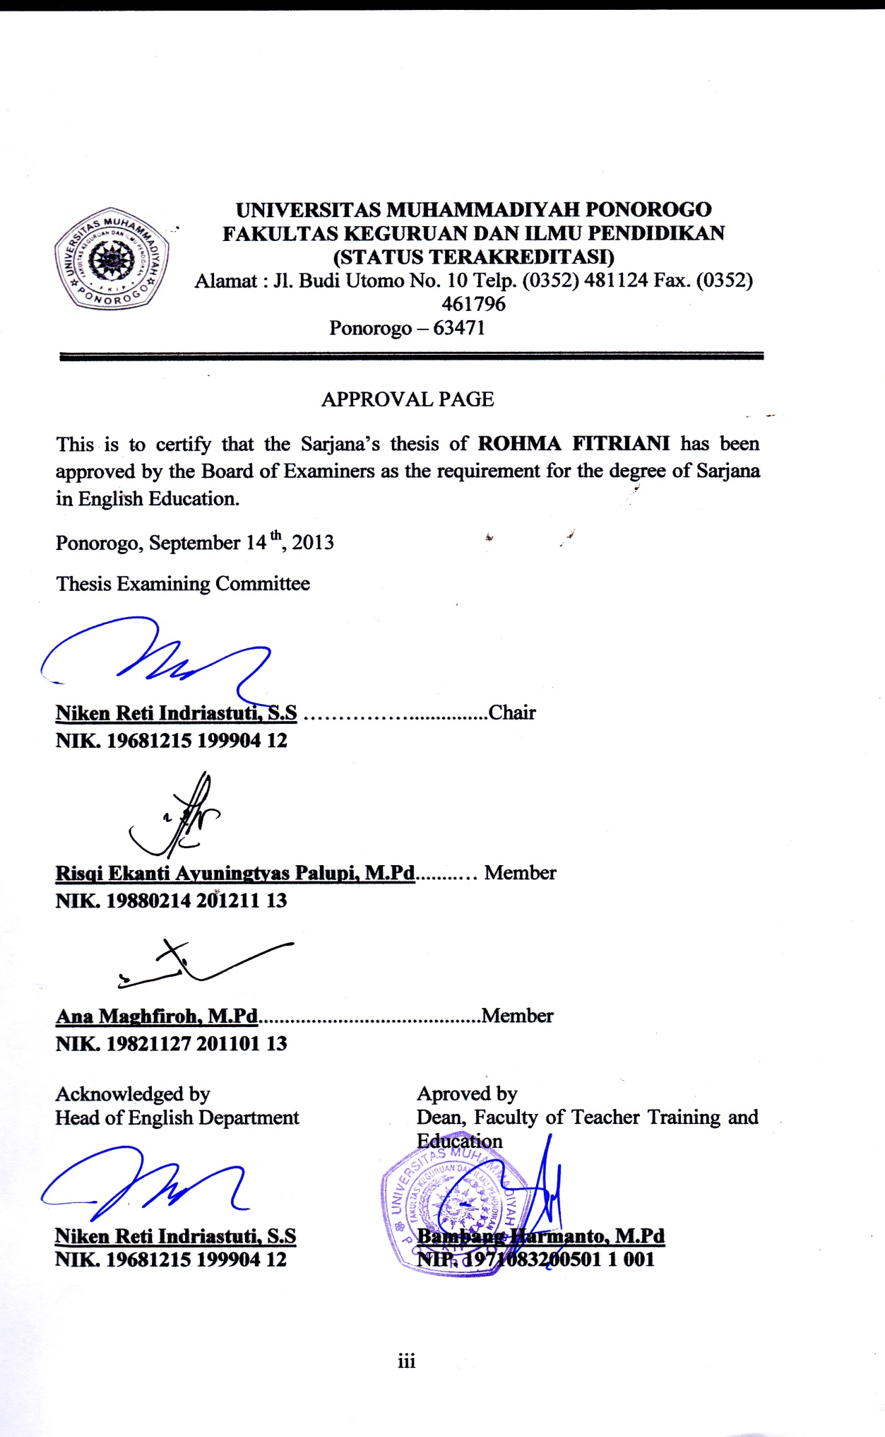

**UNIVERSITAS MUHAMMADIYAH PONOROGO**

**FAKULTAS KEGURUAN DAN ILMU PENDIDIKAN**

**(STATUS TERAKREDITAS**I)

Alamat : Jl. Budi Utomo No. 10 Telp. (0352) 481124 Fax. (0352) 461796

Ponorogo – 63471

AGREEMENT PAGE

This is to certify that the Sarjana’s thesis of **ROHMA FITRIANI** has been approved by thesis advisors for further approval by the Board of Examiners.

Ponorogo, August 1st, 2013

