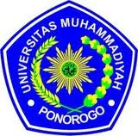
UNIVERSITAS MUHAMMADIYAH PONOROGO
FAKULTAS KEGURUAN DAN ILMU PENDIDIKAN
(STATUS TERAKREDITASI)
Alamat: Jl. Budi Utomo No. 10 Telp. (0352) 481124 Fax. (0352) 461796
PONOROGO - 63471

APPROVAL PAGE

This is to certify that the Sarjana thesis of RATIH HENING RESPATI has been approved by the Examining Committee as requirement for the Sarjana degree in English education.

Ponorogo, 23rd October 2012
Thesis Examining Committee

SITI ASIYAH, M. Pd_____________________ Chair

ANA MAGHFIROH, M. Pd_______________ Member

NIKEN RETI INDRIASTUTI, S. S__________ Member

Acknowledged by Approved by
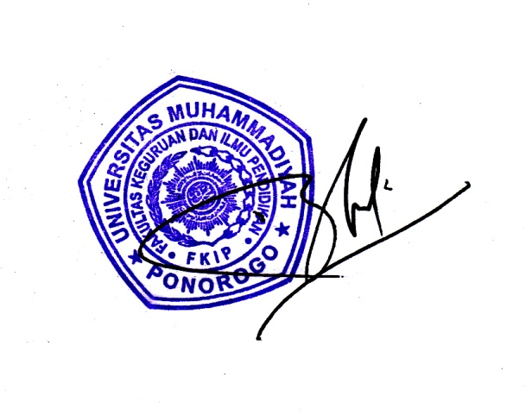
Head, English Department Dean, Faculty of Teacher
Training and Education

NIKEN RETI INDRIASTUTI. S.S BAMBANG H., M. Pd
NIS. 044 0171 NIP. 19710823 200501 1 001

