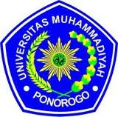
UNIVERSITAS MUHAMMADIYAH PONOROGO
FAKULTAS KEGURUAN DAN ILMU PENDIDIKAN
(STATUS TERAKREDITASI)
Alamat: Jl. Budi Utomo No. 10 Telp. (0352) 481124 Fax. (0352) 461796
PONOROGO - 63471

AGREEMENT PAGE

This is to certify that the Sarjana thesis of RATIH HENING RESPATI has been approved by the thesis advisors for further approval by the board of examiners.

Ponorogo, 22nd October 2012
Advisor I,

ZAIN ATTAMIM, M. Pd
NIS. 044 0154

Ponorogo, 22nd October 2012
Advisor II,

SITI ASIYAH, M.Pd
NIS. 044 0377

