UNIVERSITAS MUHAMMADIYAH PONOROGO
FAKULTAS KEGURUAN DAN ILMU PENDIDIKAN
(STATUS TERAKREDITASI)
Alamat : Jl. Budi Utomo No. 10 Telp. (0352) 481124 Fax. (0352) 461796
PONOROGO – 63471

APPROVAL PAGE
This is to certify that the Sarjana’s thesis of SITI MAHMUDAH has been approved by the Board of Examiners as the requirement for the degree of Sarjana in English Education.

Ponorogo, September12th, 2012
Thesis Examining Committee

Niken Reti Indriastuti, S.S ………………….. …………………..Chair
NIS. 044171
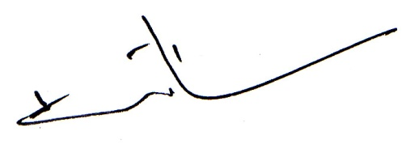

Ana Maghfiroh, M. Pd…….……..…........…….…………………..Member
NIS. 0440521

Bambang Harmanto, M.Pd ……………….………........................Member
NIP. 19710823 200501 1 001

Acknowledged by Approved by
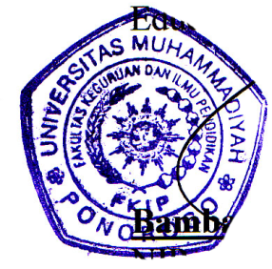
Head, English Department Dean, Faculty Teacher Training and Education

Niken Reti Indriastuti, S.S Bambang Harmanto, M.Pd
NIS. 044171 NIP. 19710823 200501 1 001
UNIVERSITAS MUHAMMADIYAH PONOROGO
FAKULTAS KEGURUAN DAN ILMU PENDIDIKAN
(STATUS TERAKREDITASI)
Alamat : Jl. Budi Utomo No. 10 Telp. (0352) 481124 Fax. (0352) 461796
PONOROGO – 63471

AGREEMENT PAGE

This is to certify that the Sarjana’s thesis of SITI MAHMUDAH has been approved by thesis advisors for further approval by the Board of Examiners.

Ponorogo, September 12th, 2012
Advisor I,

Niken Reti Indriastuti, S.S
NIS. 044171

Ponorogo, September12th,2012
Advisor II,

Ana Maghfiroh, M.Pd
NIS. 0440521

